UiPath Community Edition installation Guide

- Navigate to https://www.uipath.com/
- Click on the button “Try UiPath For Free”
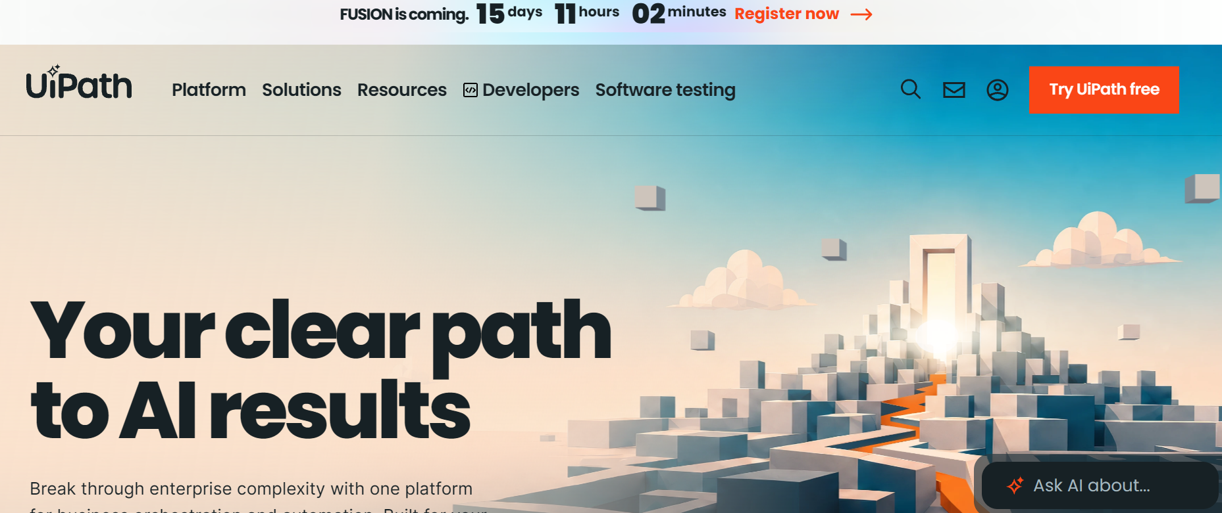
- Sign Up Interface will get loaded
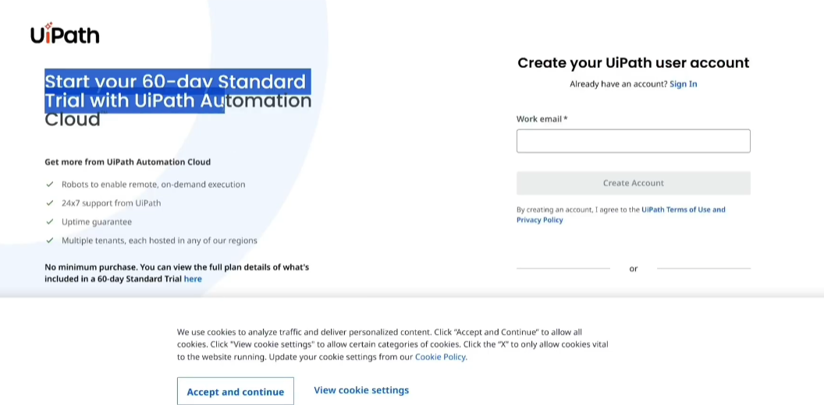
- Click on “Get Automation Cloud for Community”
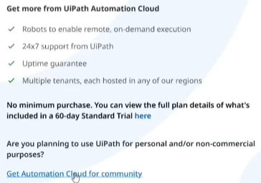
- Select “Continue with Google”
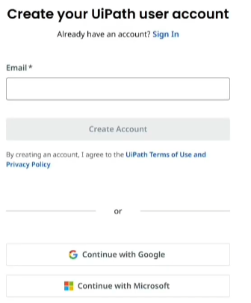
- Complete the Google authorization steps and hit “Continue” when prompted
- Post Completion of the sign up steps, will be navigated to https://cloud.uipath.com/portal__/completesignup
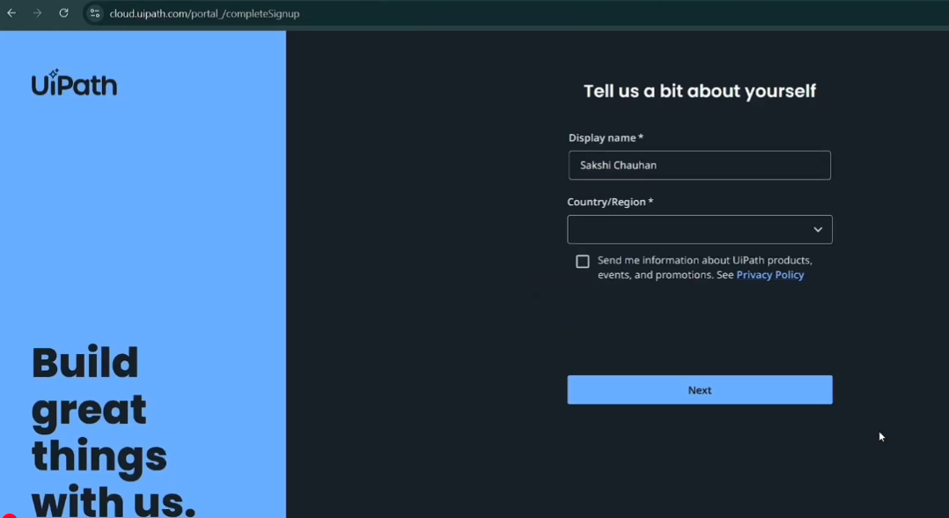
- Post Filling in the Display name, Country/Region and State. Click Next.
- Click on Create Organization. Type in the organization name of choice “Learn UiPath” for example and click create
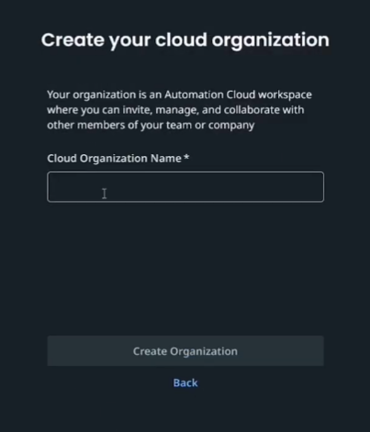
NOTE : Unique names are created so use your name like “Learn Uipath John Doe”
- Once organization is created. We will be navigated to the UiPath Automation Cloud homepage,
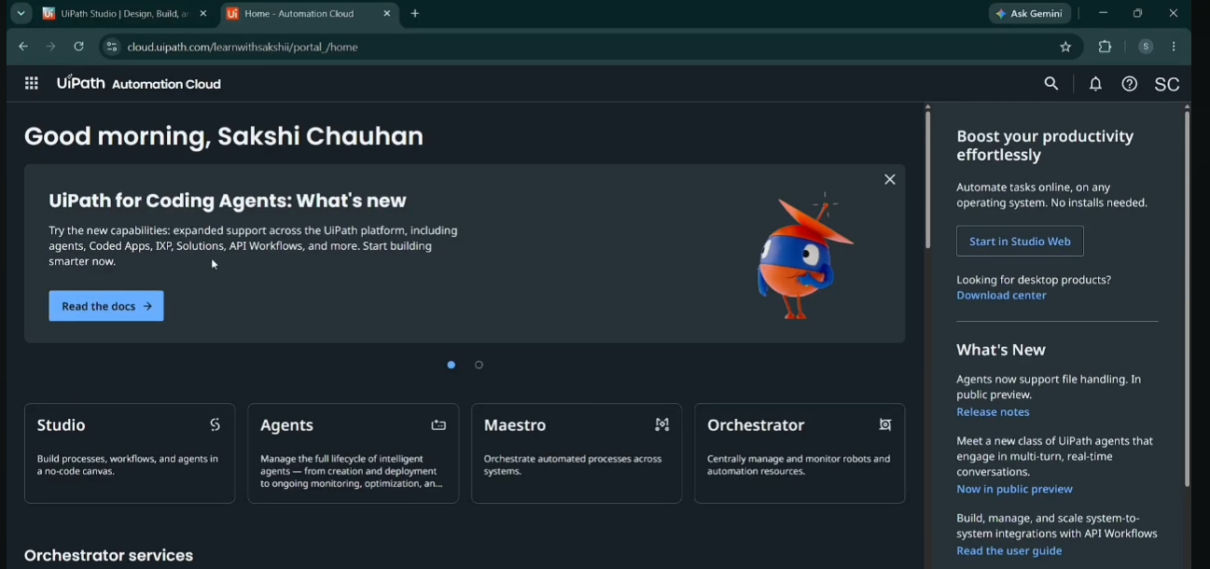
- Navigate to the Admin center using the panel by click on the 8 dots on the top left corner.
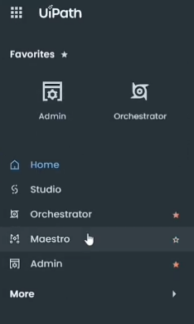
- Once the Admin Page is loaded, Click on “DefaulTenant” on the left side panel and “Services”
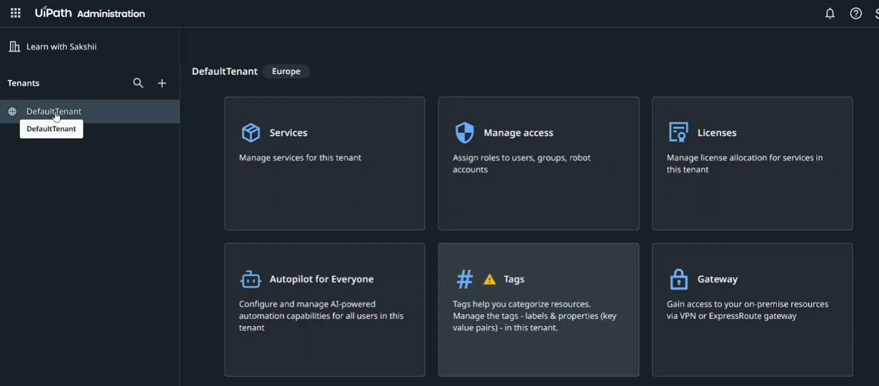
- Click on “Add Services”, “Select All” and “Add”
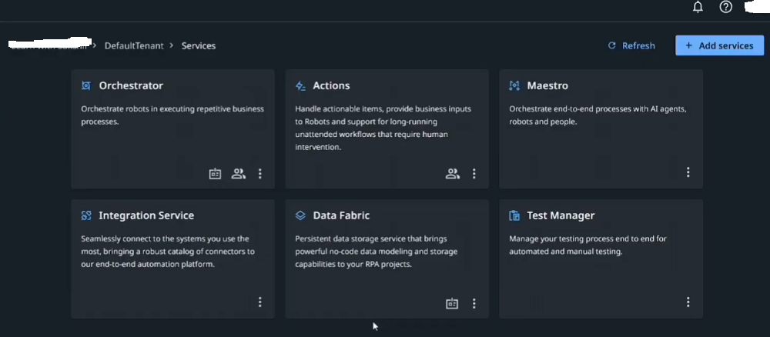
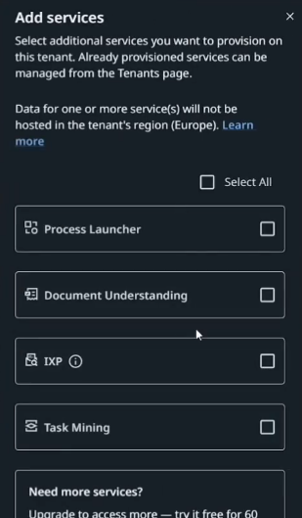
- Once the services are added. Navigate using the same 6 dots on the top left corner to “Home”
- Click on the help Icon (?) mark, and click downloads from the menu
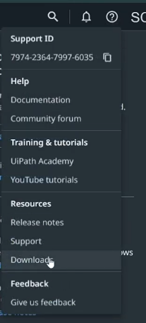
- Automatically a tab will open “Resource Center Uipath”, Under Community Edition, Click Download
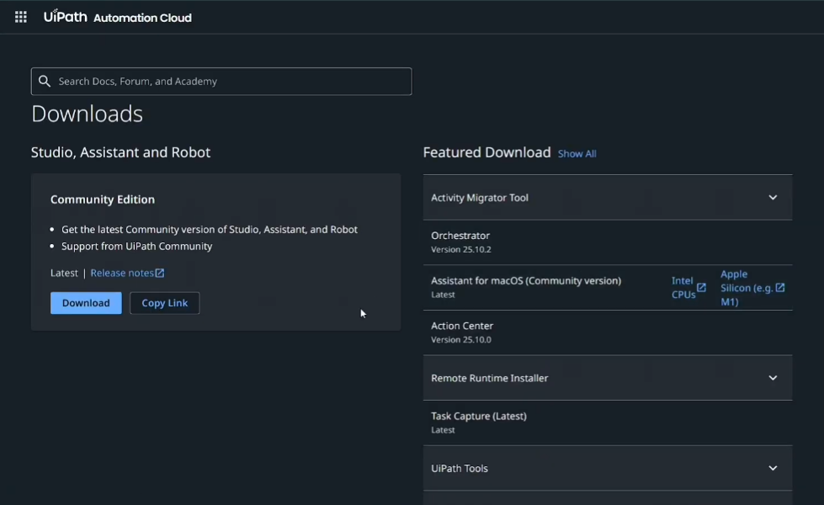
- Once Download is completed (Setup File).
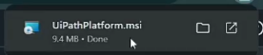
- Run the Setup,
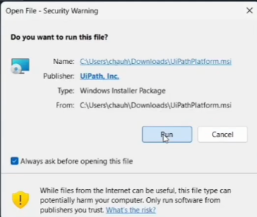
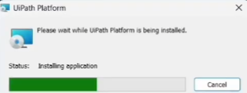
- Select Studio , Automatically Extensions will get selected. Agree to terms and click Install.
NOTE : If need be go to advance settings and change the drive path for installation in case we need to be careful of the storage space in C disk.
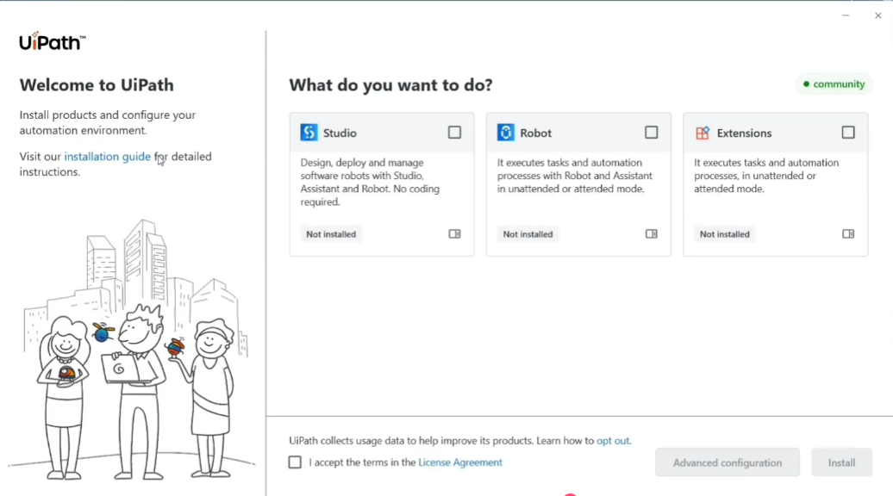
Once the installation is completed , click Close
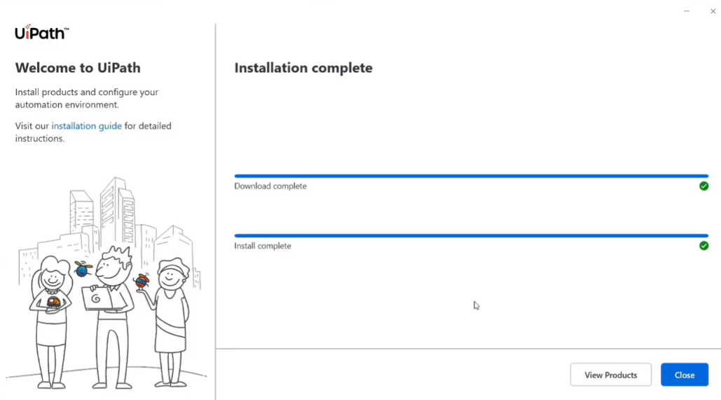
- Launch the UiPath Studio from the start menu,
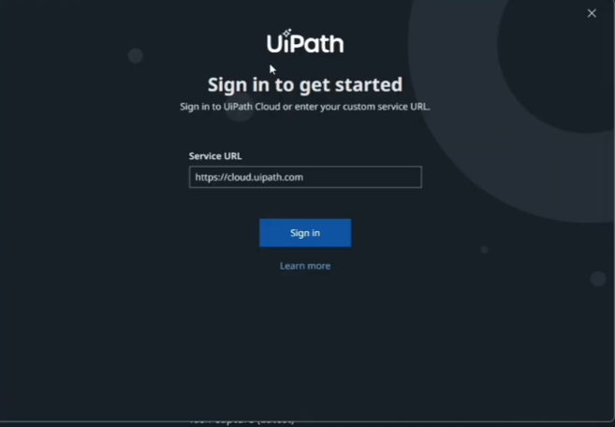
To Sign in use the same email id used when downloading / Signing up in Uipath portal. Once sign in is done, will be navigated to the browser, with a prompt, Click Open Uipath
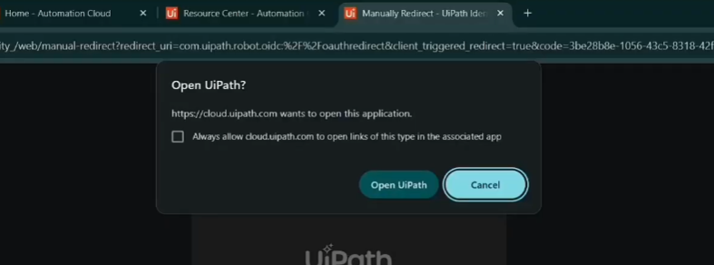

- Setup is now completed


